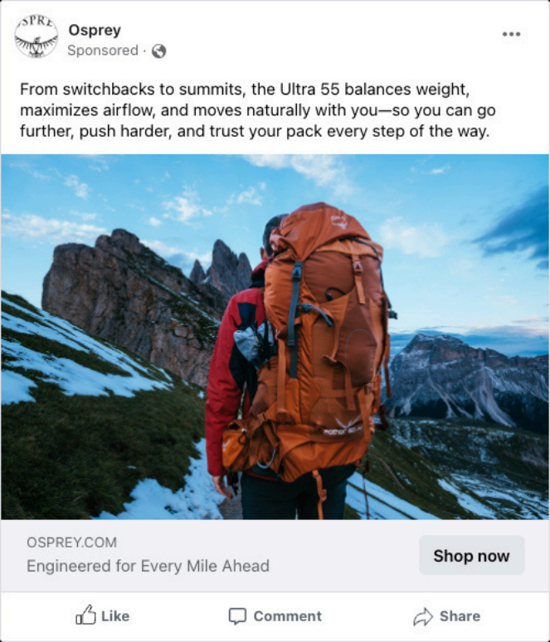
Facebook
Ad
Get long-distance hikers
Who want an ultralight pack that moves naturally with them
To consider the Ultra 55 as the pack that delivers effortless comfort, trail-tested support, durability, and spine-friendly engineering
By promising ultralight freedom without compromising performance on every mile of the trail
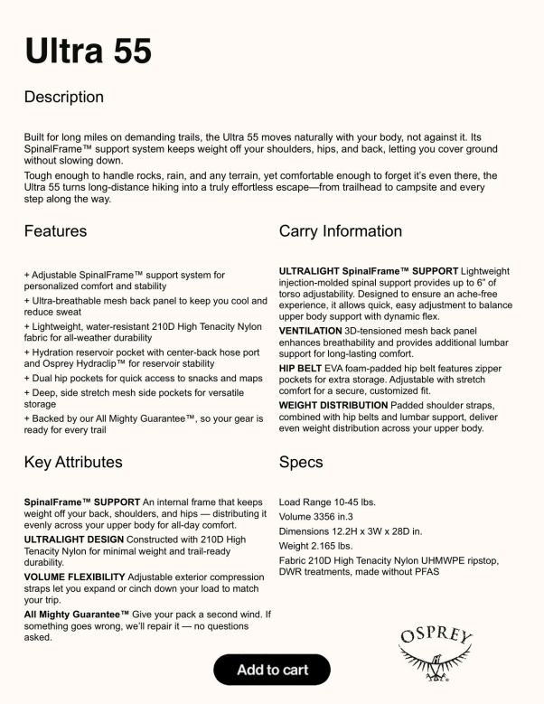
Product
Page
Get backpackers looking for long-distance comfort
Who are frustrated by ultralight packs that compromise support or durability To choose the Ultra 55 as the pack that delivers both ultralight weight and trail tested comfort
By highlighting the SpinalFrame™ support, durable 210D Nylon, breathable mesh, and features that keep shoulders, hips, and back pain-free on long treks
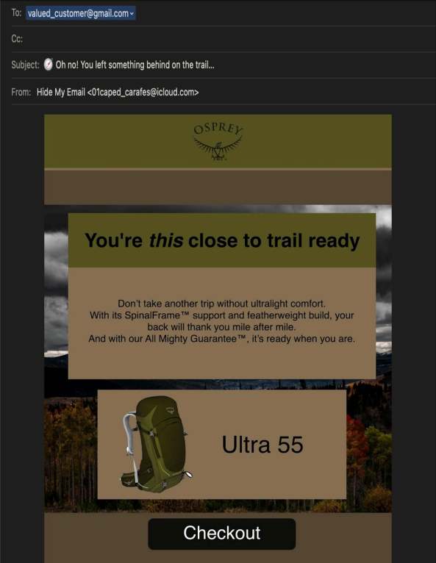
Abandoned Cart
Email
Get hesitant shoppers who left the Ultra 55 in their cart
Who still aren’t fully convinced to purchase To complete their order with confidence By using a friendly, benefit-focused email with urgency in the subject line, soft pressure in the body, and simple formatting that reduces friction and decision fatigue
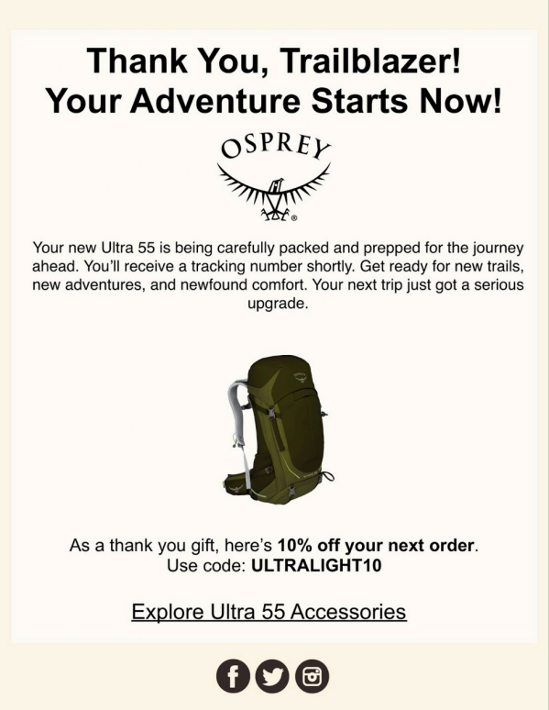
Post
Purchase
Email
Get recent Ultra 55 buyers
Who are eager to upgrade their gear To explore accessories and make another purchase
By reinforcing their “Trailblazer” identity, celebrating their choice, and offering a discount code that nudges them toward add ons and gear upsells
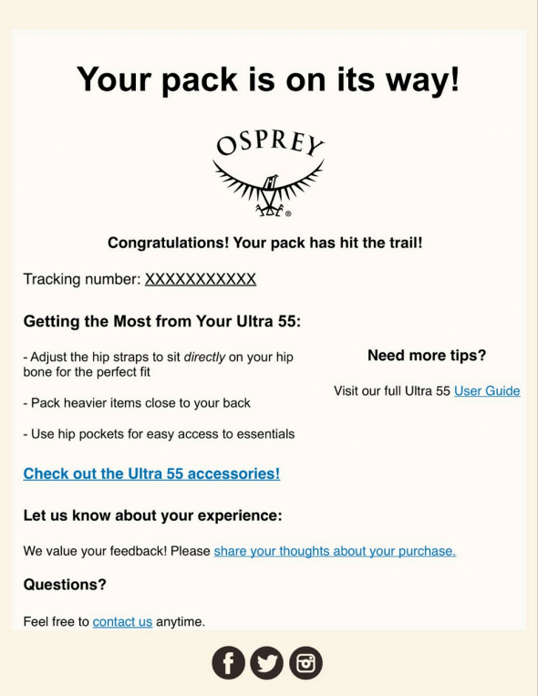
Follow
Up
Email
Get recent Ultra 55 buyers
Who are settling in with their new pack To stay engaged with the brand and explore upgrades
By offering practical usage tips, community connection, and subtle upsell opportunities that feel like added value rather than a sales pitch

